SmartSpace
An AI-Powered Web-Based Furniture Selection and 3D Room Visualization and furniture System for Personalized Space Planning
System Architecture & Implementation Plan
SUMMARY — Project Summary
A web-based intelligent furniture catalog and room visualization platform that lets customers browse furniture, visualize it in 3D rooms, check if it fits, get AI-powered style recommendations, plan budgets, and order/reserve — all in one system.

Document Version: 1.0
September 11, 2026
Status: Awaiting Approval

Table of Contents
Table of Contents 1
1 — Executive Summary 1
The Problem 1
The Solution 1
Design Philosophy: AI vs Algorithm 1
2 — System Architecture 1
High-Level Overview 1
Service Communication Flow 1
Architecture Principles 1
3 — Technology Stack 1
Frontend 1
Backend 1
AI Service 1
3D Asset Pipeline 1
4 — Database Design (ERD) 1
Entity Relationship Diagram 1
Key Table Definitions 1
users 1
furniture 1
room_projects 1
orders 1
Key Indexes 1
5 — API Specification 1
Conventions 1
Authentication 1
Furniture Catalog 1
Categories 1
Room Projects 1
AI Service (via Laravel Proxy) 1
Favorites 1
Comparisons 1
Orders / Reservations 1
Admin Endpoints 1
6 — AI Service Architecture 1
Service Design 1
FastAPI Endpoints 1
Provider Interface (Strategy Pattern) 1
Room Analysis Pipeline 1
Room Package Recommendation Pipeline 1
AI Layout Suggestion Pipeline 1
7 — 3D Engine Architecture 1
Component Architecture 1
Product 3D Viewer 1
Room Planner Layout 1
Lighting Presets 1
Space Compatibility Algorithm 1
GLB Asset Requirements 1
8 — Frontend Architecture 1
Route Structure 1
Component Hierarchy 1
State Management (Pinia) 1
9 — Backend Architecture 1
Laravel Layer Structure 1
AIServiceClient (Laravel → Python Proxy) 1
10 — Security Plan 1
Authentication & Authorization 1
Threat Mitigation 1
File Upload Validation 1
11 — Folder Structure 1
12 — Feature Breakdown 1
Feature Matrix 1
What Makes This System Special 1
13 — Development Roadmap (8 Phases) 1
Timeline Overview 1
Phase 1 — Foundation 1
Phase 2 — Catalog & Management 1
Phase 3 — 3D Integration 1
Phase 4 — Room Planner 1
Phase 5 — AI Service 1
Phase 6 — Advanced AI Features 1
Phase 7 — Orders & Admin 1
Phase 8 — Polish & Testing 1
14 — Environment & Configuration 1
Backend .env 1
Frontend .env 1
AI Service .env 1
15 — Deployment & DevOps 1
Local Development 1
Production 1
16 — Testing Strategy 1
Backend (PHPUnit) 1
Frontend (Vitest + Playwright) 1
AI Service (Pytest) 1
Run Commands 1
17 — Blender Asset Pipeline 1
Workflow 1
Naming Convention 1
Development Placeholder Models 1
18 — Setup Instructions 1
Prerequisites 1
Quick Start 1
Adding a GLB Model 1
Configuring AI Provider 1

(Right-click and choose “Update Field” to populate this table in Microsoft Word.)

1 — Executive Summary

The Problem
Problem | Impact
Will it fit? | Furniture returned due to size mismatch
Will it look good? | Style clashes with existing room décor
Will pieces work together? | Mismatched furniture combinations
Will it fit my budget? | Overspending or underutilizing budget
Can I visualize it? | No way to “try before you buy”

The Solution
SOLUTION — SmartSpace answers all five problems in one platform:
3D Room Planner with real-world dimensions
Space Compatibility Engine (deterministic — no fake AI)
AI Room Analysis from uploaded photos
AI Style Matching & Recommendations
Room Package Recommendations (full room sets)
AI Layout Suggestions (optimal furniture arrangements)
Lighting Preview (daylight, evening, warm, showroom)
Budget Planner with real-time tracking

Design Philosophy: AI vs Algorithm
IMPORTANT — Core Principle
Use AI where it provides meaningful value. Use deterministic algorithms where reliability matters more.

Use AI When | Use Algorithms When
Style matching & recommendations | Dimension calculations
Room image analysis | Collision/overlap detection
Color harmony assessment | Space compatibility scores
Natural language preferences | Budget math
Layout aesthetic optimization | Inventory/stock checks
Room package curation | Pricing & discounts
Personalized suggestions | Room boundary enforcement
Image understanding | Walking space calculations

Example:
AI: “This sofa matches the user's minimalist room style.”
Algorithm: “The sofa is 220 cm wide but the available space is only 180 cm. Therefore it does not fit.”

WARNING — Graceful Degradation
The system MUST remain fully functional if the AI service goes down. Catalog, 3D viewer, room planner, space compatibility, and budget planning work independently. Only AI-specific features (recommendations, room analysis, style matching) become unavailable.

2 — System Architecture

High-Level Overview
The platform is composed of five independent pieces — a Vue 3 single-page application, a Laravel API, a MySQL database, a Python FastAPI AI microservice, and file storage for images and 3D models — connected through a proxy pattern so the browser never talks to the AI service directly.
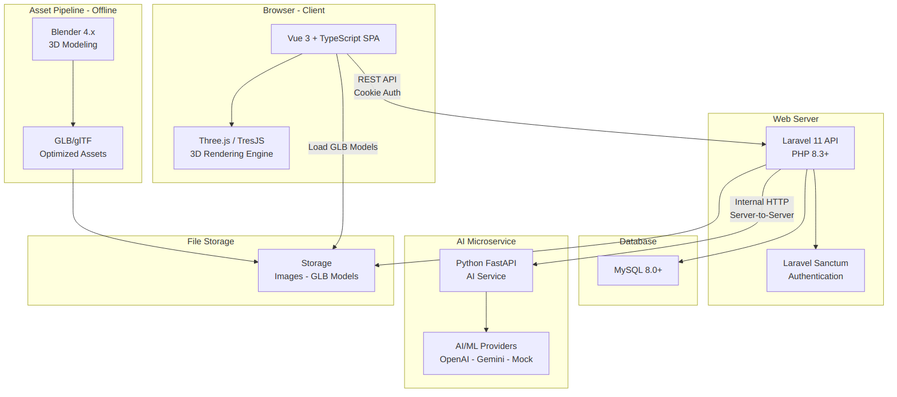
Figure 2.1 — High-level system architecture

Service Communication Flow
The sequence below traces the main request flows through the system: authentication, furniture browsing, 3D model loading, AI recommendations (proxied through Laravel), and room photo analysis.
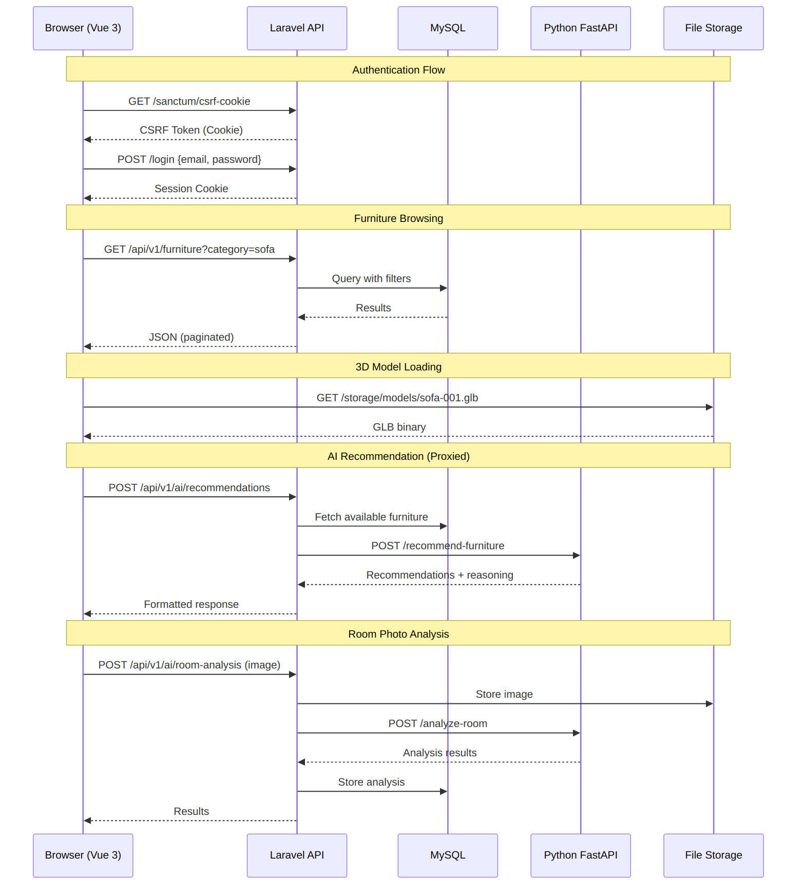
Figure 2.2 — Service communication sequence

Architecture Principles
Principle | How It's Applied
Separation of Concerns | Frontend / Backend / AI / Assets are independent
Graceful Degradation | AI down → core features still work
API-First | All data through versioned REST API
Single Source of Truth | Database/API — never hardcoded frontend data
Proxy Pattern | Browser → Laravel → AI (browser never hits AI directly)
Real Dimensions | Room planner uses actual cm-based measurements
On-Demand Loading | GLB models loaded when needed, cached after

3 — Technology Stack

Frontend
Technology | Version | Purpose
Vue 3 | 3.5+ | UI framework (Composition API + <script setup>)
TypeScript | 5.x | Full type safety
Vite | 6.x | Build tool & dev server
Tailwind CSS | 4.x | Utility-first styling
Pinia | 2.x | State management
Vue Router | 4.x | Client-side routing with guards
TresJS | 4.x | Declarative Three.js for Vue 3
@tresjs/cientos | 4.x | GLTFModel, OrbitControls, helpers
Three.js | 0.170+ | 3D engine (peer dep via TresJS)
Axios | 1.x | HTTP client with interceptors
VueUse | 11.x | Composition utilities
Chart.js | 4.x | Admin analytics charts

Backend
Technology | Version | Purpose
PHP | 8.3+ | Server language
Laravel | 11.x | API framework
Laravel Sanctum | 4.x | Cookie-based SPA auth
MySQL | 8.0+ | Database
Intervention Image | 3.x | Image processing
GuzzleHTTP | 7.x | HTTP client → AI service
PHPUnit | 11.x | Testing

AI Service
Technology | Version | Purpose
Python | 3.11+ | AI service language
FastAPI | 0.115+ | Async API framework
Uvicorn | 0.30+ | ASGI server
Pydantic | 2.x | Validation
Pillow | 10.x | Image processing
scikit-learn | 1.5+ | ML algorithms
NumPy | 2.x | Numerical computation
OpenAI SDK | latest | LLM integration (pluggable)
Google AI SDK | latest | Gemini integration (pluggable)

3D Asset Pipeline
Tool | Purpose
Blender 4.x | 3D modeling, UV mapping, materials
glTF-Transform CLI | GLB optimization, Draco compression
Three.js GLTFLoader | Runtime model loading
Draco Decoder | Mesh decompression (self-hosted)

4 — Database Design (ERD)

Entity Relationship Diagram
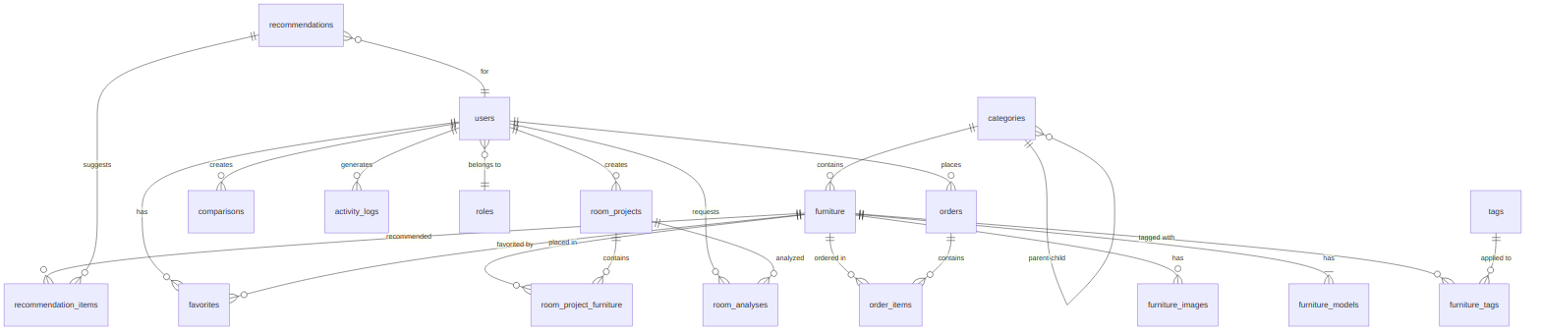
Figure 4.1 — Entity relationship diagram (17 tables)
Table Count: 17 tables

Key Table Definitions

users
CREATE TABLE users (
id BIGINT UNSIGNED AUTO_INCREMENT PRIMARY KEY,
name VARCHAR(255) NOT NULL,
email VARCHAR(255) NOT NULL UNIQUE,
password VARCHAR(255) NOT NULL,
role_id BIGINT UNSIGNED NOT NULL DEFAULT 2, -- 1=admin, 2=customer
phone VARCHAR(20) NULL,
avatar VARCHAR(500) NULL,
preferences JSON NULL, -- {preferred_style, preferred_colors, budget_range}
email_verified_at TIMESTAMP NULL,
remember_token VARCHAR(100) NULL,
created_at TIMESTAMP NULL,
updated_at TIMESTAMP NULL,
INDEX idx_users_role (role_id),
FOREIGN KEY (role_id) REFERENCES roles(id)
);

furniture
CREATE TABLE furniture (
id BIGINT UNSIGNED AUTO_INCREMENT PRIMARY KEY,
sku VARCHAR(50) NOT NULL UNIQUE,
name VARCHAR(255) NOT NULL,
description TEXT NULL,
category_id BIGINT UNSIGNED NOT NULL,
price DECIMAL(12,2) NOT NULL,
discount_price DECIMAL(12,2) NULL,
stock_quantity INT UNSIGNED NOT NULL DEFAULT 0,
availability_status ENUM('in_stock','low_stock','out_of_stock','pre_order','discontinued')
NOT NULL DEFAULT 'in_stock',
material VARCHAR(100) NULL,
color VARCHAR(100) NULL,
style VARCHAR(100) NULL,
width_cm DECIMAL(8,2) NOT NULL,
height_cm DECIMAL(8,2) NOT NULL,
depth_cm DECIMAL(8,2) NOT NULL,
weight_kg DECIMAL(8,2) NULL,
glb_model_path VARCHAR(500) NULL,
is_featured BOOLEAN NOT NULL DEFAULT FALSE,
is_active BOOLEAN NOT NULL DEFAULT TRUE,
metadata JSON NULL,
created_at TIMESTAMP NULL,
updated_at TIMESTAMP NULL,

INDEX idx_furniture_category (category_id),
INDEX idx_furniture_style (style),
INDEX idx_furniture_price (price),
INDEX idx_furniture_availability (availability_status),
INDEX idx_furniture_active (is_active),
FULLTEXT idx_furniture_search (name, description),
FOREIGN KEY (category_id) REFERENCES categories(id)
);

room_projects
CREATE TABLE room_projects (
id BIGINT UNSIGNED AUTO_INCREMENT PRIMARY KEY,
user_id BIGINT UNSIGNED NOT NULL,
name VARCHAR(255) NOT NULL,
room_type VARCHAR(50) NULL,
width_cm DECIMAL(8,2) NOT NULL,
length_cm DECIMAL(8,2) NOT NULL,
height_cm DECIMAL(8,2) NULL DEFAULT 270,
style VARCHAR(100) NULL,
room_image_path VARCHAR(500) NULL,
settings JSON NULL, -- {wall_color, floor_type, lighting_preset}
budget DECIMAL(12,2) NULL,
created_at TIMESTAMP NULL,
updated_at TIMESTAMP NULL,
INDEX idx_room_projects_user (user_id),
FOREIGN KEY (user_id) REFERENCES users(id) ON DELETE CASCADE
);

orders
CREATE TABLE orders (
id BIGINT UNSIGNED AUTO_INCREMENT PRIMARY KEY,
user_id BIGINT UNSIGNED NOT NULL,
order_number VARCHAR(20) NOT NULL UNIQUE,
status ENUM('pending','confirmed','processing','ready','completed','cancelled')
NOT NULL DEFAULT 'pending',
subtotal DECIMAL(12,2) NOT NULL,
discount_total DECIMAL(12,2) NOT NULL DEFAULT 0,
total DECIMAL(12,2) NOT NULL,
notes TEXT NULL,
shipping_info JSON NULL,
created_at TIMESTAMP NULL,
updated_at TIMESTAMP NULL,
INDEX idx_orders_user (user_id),
INDEX idx_orders_status (status),
FOREIGN KEY (user_id) REFERENCES users(id)
);

Key Indexes
Table | Index Name | Columns | Type
furniture | idx_furniture_search | name, description | FULLTEXT
furniture | idx_furniture_category | category_id | B-TREE
furniture | idx_furniture_price | price | B-TREE
furniture | idx_furniture_style | style | B-TREE
furniture | idx_furniture_availability | availability_status | B-TREE
room_projects | idx_room_projects_user | user_id | B-TREE
orders | idx_orders_status | status | B-TREE
favorites | unique_user_furniture | user_id, furniture_id | UNIQUE
activity_logs | idx_activity_user | user_id, action | COMPOSITE

5 — API Specification

Conventions
Base URL: /api/v1
Auth: Laravel Sanctum cookie-based SPA authentication
Content-Type: application/json (file uploads: multipart/form-data)
Pagination: ?page=1&per_page=20

Success Response:
{
"success": true,
"data": { ... },
"meta": { "current_page": 1, "total": 150 },
"message": "Furniture retrieved successfully"
}

Error Response:
{
"success": false,
"message": "Validation failed",
"errors": { "email": ["The email field is required."] }
}

Authentication
Method | Endpoint | Description | Auth
GET | /sanctum/csrf-cookie | Initialize CSRF | No
POST | /api/v1/auth/register | Register customer | No
POST | /api/v1/auth/login | Login | No
POST | /api/v1/auth/logout | Logout | Yes
GET | /api/v1/auth/user | Get current user | Yes
PUT | /api/v1/auth/profile | Update profile | Yes
PUT | /api/v1/auth/password | Change password | Yes

Furniture Catalog
Method | Endpoint | Description | Auth
GET | /api/v1/furniture | List (paginated, filterable) | No
GET | /api/v1/furniture/{id} | Detail | No
GET | /api/v1/furniture/{id}/related | Related items | No
GET | /api/v1/furniture/featured | Featured items | No
GET | /api/v1/furniture/search | Full-text search | No

Query Parameters for /api/v1/furniture:
?category={slug}
&subcategory={slug}
&style={minimalist|modern|scandinavian|industrial|...}
&color={white|black|brown|...}
&material={wood|metal|fabric|leather|...}
&min_price={number}
&max_price={number}
&min_width={cm} &max_width={cm}
&min_height={cm} &max_height={cm}
&min_depth={cm} &max_depth={cm}
&availability={in_stock|low_stock}
&sort={price_asc|price_desc|name_asc|newest|popular}
&search={text}
&page={n} &per_page={n}

Categories
Method | Endpoint | Description | Auth
GET | /api/v1/categories | List all (tree structure) | No
GET | /api/v1/categories/{slug} | Category + counts | No

Room Projects
Method | Endpoint | Description | Auth
GET | /api/v1/rooms | List user's rooms | Customer
POST | /api/v1/rooms | Create room | Customer
GET | /api/v1/rooms/{id} | Get room + furniture | Customer
PUT | /api/v1/rooms/{id} | Update room | Customer
DELETE | /api/v1/rooms/{id} | Delete room | Customer
POST | /api/v1/rooms/{id}/furniture | Add furniture | Customer
PUT | /api/v1/rooms/{id}/furniture/{rpfId} | Update position/rotation | Customer
DELETE | /api/v1/rooms/{id}/furniture/{rpfId} | Remove furniture | Customer
POST | /api/v1/rooms/{id}/furniture/{rpfId}/duplicate | Duplicate item | Customer
GET | /api/v1/rooms/{id}/compatibility | Space compatibility report | Customer
GET | /api/v1/rooms/{id}/budget | Budget breakdown | Customer
POST | /api/v1/rooms/{id}/image | Upload room photo | Customer

AI Service (via Laravel Proxy)
Method | Endpoint | Description | Auth
POST | /api/v1/ai/room-analysis | Analyze room photo | Customer
POST | /api/v1/ai/recommendations | Get recommendations | Customer
POST | /api/v1/ai/style-match | Style compatibility | Customer
POST | /api/v1/ai/room-package | Complete room package | Customer
POST | /api/v1/ai/layout-suggestion | AI layout arrangement | Customer
GET | /api/v1/ai/status | AI service health | No

Recommendation Request Body:
{
"room_type": "bedroom",
"room_width_cm": 400,
"room_length_cm": 500,
"budget": 50000,
"currency": "PHP",
"preferred_style": "minimalist",
"preferred_colors": ["white", "light wood"],
"preferred_materials": ["wood", "fabric"],
"existing_furniture_ids": [12, 45],
"room_analysis_id": 7,
"package_mode": true
}

Layout Suggestion Request Body:
{
"room_project_id": 15,
"furniture_ids": [12, 45, 78, 91],
"optimization_goal": "spacious"
}

Favorites
Method | Endpoint | Description | Auth
GET | /api/v1/favorites | List favorites | Customer
POST | /api/v1/favorites | Add favorite | Customer
DELETE | /api/v1/favorites/{furnitureId} | Remove favorite | Customer

Comparisons
Method | Endpoint | Description | Auth
GET | /api/v1/comparisons | List saved comparisons | Customer
POST | /api/v1/comparisons | Create comparison | Customer
GET | /api/v1/comparisons/{id} | Get comparison | Customer
DELETE | /api/v1/comparisons/{id} | Delete comparison | Customer
GET | /api/v1/furniture/compare?ids=1,2,3 | Quick compare | No

Orders / Reservations
Method | Endpoint | Description | Auth
GET | /api/v1/orders | List user's orders | Customer
POST | /api/v1/orders | Create order | Customer
GET | /api/v1/orders/{id} | Order detail | Customer
PUT | /api/v1/orders/{id}/cancel | Cancel order | Customer

Admin Endpoints
Method | Endpoint | Description | Auth
GET | /api/v1/admin/dashboard | Dashboard stats | Admin
POST | /api/v1/admin/furniture | Create furniture | Admin
PUT | /api/v1/admin/furniture/{id} | Update furniture | Admin
DELETE | /api/v1/admin/furniture/{id} | Delete furniture | Admin
POST | /api/v1/admin/furniture/{id}/images | Upload images | Admin
DELETE | /api/v1/admin/furniture/{id}/images/{imgId} | Delete image | Admin
POST | /api/v1/admin/furniture/{id}/model | Upload GLB | Admin
POST | /api/v1/admin/categories | Create category | Admin
PUT | /api/v1/admin/categories/{id} | Update category | Admin
DELETE | /api/v1/admin/categories/{id} | Delete category | Admin
GET | /api/v1/admin/orders | All orders | Admin
PUT | /api/v1/admin/orders/{id}/status | Update status | Admin
GET | /api/v1/admin/customers | List customers | Admin
GET | /api/v1/admin/customers/{id} | Customer detail | Admin
GET | /api/v1/admin/inventory | Inventory overview | Admin
PUT | /api/v1/admin/inventory/{furnitureId} | Update stock | Admin
GET | /api/v1/admin/analytics/rooms | Room analytics | Admin
GET | /api/v1/admin/analytics/furniture | Furniture analytics | Admin

Legend: No = No auth · Yes = Authenticated · Customer = Customer role · Admin = Admin role

6 — AI Service Architecture

Service Design
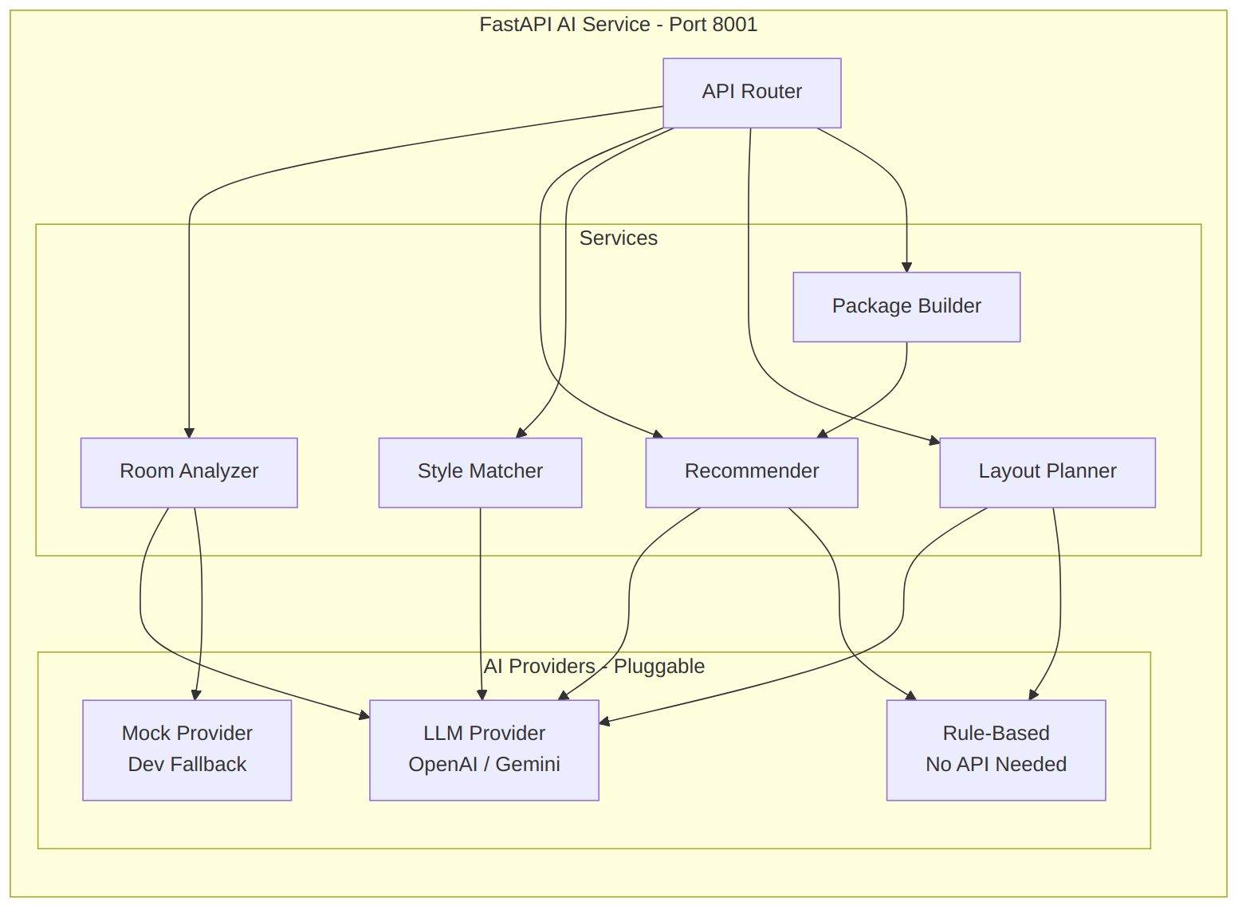
Figure 6.1 — FastAPI AI service internal design

FastAPI Endpoints
Method | Endpoint | Description
POST | /analyze-room | Analyze room image
POST | /recommend-furniture | Generate recommendations
POST | /style-match | Style compatibility score
POST | /suggest-layout | Optimal furniture layout
POST | /room-package | Complete room set
GET | /health | Service health check

Provider Interface (Strategy Pattern)
from abc import ABC, abstractmethod

class AIProvider(ABC):
"""Pluggable AI provider — swap without changing business logic."""

@abstractmethod
async def analyze_image(self, image_path: str) -> RoomAnalysis: ...

@abstractmethod
async def get_recommendations(
self, criteria: RecommendationCriteria,
catalog: list[FurnitureItem]
) -> list[Recommendation]: ...

@abstractmethod
async def compute_style_match(
self, room_style: str, furniture_style: str
) -> StyleMatchResult: ...

@abstractmethod
async def suggest_layout(
self, room: RoomSpec, furniture: list[FurnitureItem]
) -> LayoutSuggestion: ...

# Available implementations:
class OpenAIProvider(AIProvider): ... # GPT-4o + GPT-4 Vision
class GeminiProvider(AIProvider): ... # Gemini 2.0 Flash
class MockProvider(AIProvider): ... # Dev fallback (realistic mock data)
class RuleBasedProvider(AIProvider): ... # Deterministic rules (no API key)

Room Analysis Pipeline
Input: Room Photo (JPG/PNG/WebP)
|
v
+----------------------+
| 1. Image Validation | <- Format, size, is-a-room check
+----------+-----------+
|
v
+----------------------+
| 2. Vision Analysis | <- GPT-4V / Gemini Vision / CLIP
| |
| Extracts: |
| - Room type | bedroom / living room / office
| - Dominant colors | hex palette
| - Design style | minimalist / modern / rustic
| - Existing items | detected furniture types
| - Lighting mood | bright / warm / dim
| - Characteristics | spacious / compact / L-shaped
+----------+-----------+
|
v
+----------------------+
| 3. Recommendations | <- Map analysis -> catalog items
| |
| Considers: |
| - Style match | room style -> furniture style
| - Color harmony | room colors -> furniture colors
| - Category fit | room type -> categories
| - User preferences | history, favorites, budget
+----------+-----------+
|
v
Output: {
room_type, detected_style, dominant_colors,
lighting, characteristics, existing_furniture,
recommended_categories, recommended_ids,
confidence, reasoning
}

Room Package Recommendation Pipeline
Input: {room_type, dimensions, budget, style, colors}
|
v
+---------------------------+
| 1. CATEGORY SELECTION | <- Deterministic
| Living Room needs: |
| - Sofa (required) |
| - Coffee Table |
| - TV Stand |
| - Side Table |
| - Bookshelf (opt.) |
| - Decor (opt.) |
+-------------+-------------+
|
v
+---------------------------+
| 2. BUDGET ALLOCATION | <- Deterministic
| Total: PHP 80,000 |
| Sofa: 35-45% |
| Coffee Tbl: 8-12% |
| TV Stand: 12-18% |
| Side Table: 5-8% |
| Others: remaining |
+-------------+-------------+
|
v
+---------------------------+
| 3. DIMENSIONAL FILTER | <- Deterministic
| Room: 400x500 cm |
| Max sofa width: ~300 |
| Verify all items fit |
+-------------+-------------+
|
v
+---------------------------+
| 4. AI STYLE SELECTION | <- AI-Powered
| Pick best-matching |
| items per category |
| for style + color |
| coherence |
+-------------+-------------+
|
v
Output: {
name: "Modern Minimalist Living Room Set",
items: [...],
total_cost, budget_remaining,
style_coherence_score,
space_utilization,
reasoning
}

AI Layout Suggestion Pipeline
Input: {room_dimensions, furniture_with_dimensions}
|
v
+----------------------------+
| 1. CONSTRAINT ANALYSIS | <- Deterministic
| - Room boundaries |
| - Door/window zones |
| - Min clearance: 60cm |
| - Walking paths |
+--------------+-------------+
|
v
+----------------------------+
| 2. LAYOUT RULES | <- Deterministic
| - Sofa faces TV stand |
| - Coffee table -> sofa |
| - Desk near window |
| - Bed against wall |
+--------------+-------------+
|
v
+----------------------------+
| 3. AI OPTIMIZATION | <- AI-Powered
| - Aesthetic balance |
| - Flow optimization |
| - Multiple options |
+--------------+-------------+
|
v
Output: {
layouts: [
{ name: "Open Flow", positions: [...], score: 88 },
{ name: "Cozy Corner", positions: [...], score: 82 }
]
}

CAUTION — Development Mode
When AI_PROVIDER=mock, all AI responses include "_mock": true and a notice that the AI service is not configured and this is development data — the frontend displays a clear badge so users know the results are demo data.

7 — 3D Engine Architecture

Component Architecture
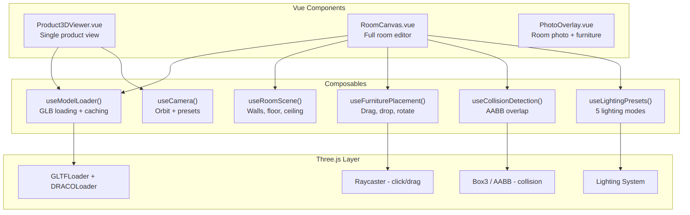
Figure 7.1 — 3D engine component architecture

Product 3D Viewer
+---------------------------------------+
| Product 3D Viewer |
| |
| +-----------------------+ |
| | | |
| | [ 3D Furniture ] | |
| | Rotate | |
| | Zoom | |
| | Pan | |
| | | |
| +-----------------------+ |
| |
| [ Front ] [ Side ] [ Top ] |
| [ Reset Camera ] |
| |
| 220W x 85H x 90D cm |
+---------------------------------------+

Features:
- OrbitControls — rotate, zoom, pan
- Preset camera buttons — front, side, top, 3/4 view
- Auto-rotate toggle
- Dimension labels overlaid
- Loading progress indicator
- Model cached after first load

Room Planner Layout
+----------------------------------------------------------------+
| Room Planner: "My Living Room" [Save] |
+----------+-------------------------------------------------------+
| | |
| Tools | 3D Room View |
| | +---------------------+ |
| [+ Add] | | +--+ | |
| [Move] | | |TV| | |
| [Rotate] | | +--+ | |
| [Delete] | | | |
| [Dup] | | +--------+ +--+ | |
| | | | Sofa | |T | | |
| Light | | +--------+ +--+ | |
| [Day] | | +----+ | |
| [Gold] | | |Coff| | |
| [Eve] | | +----+ | |
| [Show] | +---------------------+ |
| [Night] | View: [2D Top-Down] [3D Perspective] |
| | |
| Room | Compatibility: 85% GOOD FIT |
| 400x500 | Budget: PHP 39,000 / 50,000 (PHP 11,000 remaining) |
| | |
+----------+-------------------------------------------------------+
| Furniture: Sofa - Coffee Table - TV Stand - Chair |
+----------------------------------------------------------------+

Lighting Presets
Preset | Ambient | Directional / Point | Color | Feel
Daylight | 0.8 | Dir: 1.0 | #FFFAF0 | Bright, neutral
Golden Hour | 0.5 | Dir: 0.8 | #FFD700 | Warm, golden
Evening | 0.3 | Point: 0.6 | #FFA500 | Dim, cozy
Showroom | 1.0 | Dir: 0.5 | #FFFFFF | Even, bright
Night | 0.15 | Spot: 0.4 | #4169E1 | Very dim, accent

Space Compatibility Algorithm
INFO
This is 100% deterministic — no AI involved.

SPACE COMPATIBILITY SCORING
============================

Input:
room = { width_cm, length_cm }
furniture[] = { width_cm, depth_cm, position_x, position_y, rotation }

----------------------------

STEP 1: BOUNDARY CHECK (30 points max)
For each item:
-> Calculate bounding box after rotation
-> Check: fully within room boundaries?
-> FAIL (instant 0 total) if ANY item extends beyond room
Score: 30 if all pass

STEP 2: OVERLAP CHECK (25 points max)
For each pair of items:
-> AABB intersection test
-> FAIL (instant 0 total) if ANY items overlap
Score: 25 if no overlaps

STEP 3: WALL CLEARANCE (15 points max)
For each item:
-> Distance to nearest wall
-> Ideal: >= 10 cm (unless against-wall furniture type)
Score: proportional to clearance quality

STEP 4: WALKING SPACE (20 points max)
-> walking_ratio = (room_area - furniture_area) / room_area
-> >= 50% open -> 20 pts
-> 40-50% -> 15 pts
-> 30-40% -> 10 pts
-> 20-30% -> 5 pts
-> < 20% -> 0 pts

STEP 5: CLEARANCE BETWEEN ITEMS (10 points max)
For each adjacent pair:
-> Minimum gap between items
-> Ideal: >= 60 cm (walking clearance)
Score: proportional to gap adequacy

----------------------------

TOTAL = Step1 + Step2 + Step3 + Step4 + Step5 (max 100)

VERDICT:
90-100 -> "EXCELLENT FIT"
70-89 -> "GOOD FIT"
50-69 -> "LIMITED SPACE"
30-49 -> "TIGHT FIT"
0-29 -> "DOES NOT FIT"

SPECIAL: If Step 1 or Step 2 FAIL -> automatic "DOES NOT FIT" (0 score)

GLB Asset Requirements
Property | Requirement
Format | GLB (binary glTF 2.0)
Max file size | 5 MB (target: 1–2 MB)
Max polygons | 50,000 (target: 10K–30K)
Textures | Max 2048×2048, prefer 1024
Materials | PBR Metallic-Roughness
Origin | Center-bottom (floor level)
Scale | 1 unit = 1 meter
Up axis | Y-up
Compression | Draco recommended
Naming | {style}-{type}-{id}.glb

8 — Frontend Architecture

Route Structure
PUBLIC
/ -> Home
/catalog -> Furniture Catalog
/catalog/:slug -> Category View
/furniture/:id -> Product Details
/login -> Login
/register -> Register

CUSTOMER (auth required)
/dashboard -> Customer Dashboard
/rooms -> My Room Designs
/rooms/new -> Create Room
/rooms/:id -> Room Planner Editor
/rooms/:id/photo -> Photo Visualization
/favorites -> My Favorites
/compare -> Compare Furniture
/recommendations -> AI Recommendations
/orders -> My Orders
/profile -> Edit Profile

ADMIN (admin role required)
/admin -> Admin Dashboard
/admin/furniture -> Furniture Management
/admin/furniture/new -> Add Furniture
/admin/furniture/:id/edit -> Edit Furniture
/admin/categories -> Category Management
/admin/inventory -> Inventory
/admin/orders -> Order Management
/admin/customers -> Customer Management
/admin/analytics -> Analytics

Component Hierarchy
App.vue
|-- layouts/
| |-- PublicLayout.vue
| |-- CustomerLayout.vue
| `-- AdminLayout.vue
|
|-- components/shared/ <- Reusable across all features
| |-- BaseButton.vue
| |-- BaseInput.vue
| |-- BaseSelect.vue
| |-- BaseModal.vue
| |-- BaseCard.vue
| |-- BaseLoader.vue
| |-- BasePagination.vue
| |-- BaseBadge.vue
| |-- BaseToast.vue
| |-- PriceDisplay.vue
| |-- DimensionDisplay.vue
| `-- AIIndicator.vue <- Shows AI vs mock status
|
|-- features/catalog/
| |-- components/
| | |-- FurnitureCard.vue
| | |-- FurnitureGrid.vue
| | |-- CatalogFilters.vue
| | |-- CatalogSearch.vue
| | |-- CategoryNav.vue
| | `-- FurnitureQuickView.vue
| |-- composables/useFurnitureFilters.ts
| |-- stores/catalogStore.ts
| `-- api/furnitureApi.ts
|
|-- features/product/
| |-- components/
| | |-- ProductGallery.vue
| | |-- ProductInfo.vue
| | |-- ProductDimensions.vue
| | |-- Product3DViewer.vue
| | |-- ProductActions.vue
| | `-- RelatedProducts.vue
| `-- ...
|
|-- features/room-planner/
| |-- components/
| | |-- RoomCanvas.vue
| | |-- RoomFloor.vue
| | |-- RoomWalls.vue
| | |-- FurnitureObject.vue
| | |-- RoomToolbar.vue
| | |-- FurniturePicker.vue
| | |-- CompatibilityPanel.vue
| | |-- BudgetPanel.vue
| | |-- LightingControls.vue
| | |-- RoomSettings.vue
| | `-- LayoutSuggestions.vue
| |-- composables/
| | |-- useRoomScene.ts
| | |-- useFurniturePlacement.ts
| | |-- useCollisionDetection.ts
| | |-- useSpaceCompatibility.ts
| | |-- useLightingPresets.ts
| | `-- useModelLoader.ts
| `-- stores/roomPlannerStore.ts
|
|-- features/ai/
| |-- components/
| | |-- RoomAnalysisResult.vue
| | |-- RecommendationCard.vue
| | |-- StyleMatchMeter.vue
| | |-- RoomPackageCard.vue
| | `-- AIStatusBadge.vue
| |-- composables/useAIService.ts
| `-- api/aiApi.ts
|
|-- features/compare/
|-- features/favorites/
|-- features/orders/
|-- features/auth/
`-- features/admin/

State Management (Pinia)
Store | Scope | Key State
useAuthStore | Global | user, isAuthenticated, role
useCatalogStore | Feature | furniture list, filters, pagination
useRoomPlannerStore | Feature | room dims, furniture placements, compatibility
useFavoritesStore | Feature | favorite IDs
useCompareStore | Feature | compared IDs (max 4)
useCartStore | Feature | order items
useUIStore | Global | toasts, modals, loading

9 — Backend Architecture

Laravel Layer Structure
app/
|-- Http/
| |-- Controllers/
| | |-- Api/V1/ <- Public/Customer endpoints
| | | |-- AuthController.php
| | | |-- FurnitureController.php
| | | |-- CategoryController.php
| | | |-- RoomProjectController.php
| | | |-- RoomFurnitureController.php
| | | |-- FavoriteController.php
| | | |-- ComparisonController.php
| | | |-- OrderController.php
| | | |-- AIProxyController.php
| | | `-- ProfileController.php
| | `-- Admin/ <- Admin endpoints
| | |-- DashboardController.php
| | |-- FurnitureManagementController.php
| | |-- CategoryManagementController.php
| | |-- InventoryController.php
| | |-- OrderManagementController.php
| | |-- CustomerController.php
| | `-- AnalyticsController.php
| |
| |-- Requests/ <- FormRequest validation
| |-- Resources/ <- API Resources / DTOs
| `-- Middleware/
| |-- EnsureAdmin.php
| `-- TrackActivity.php
|
|-- Models/ <- 15+ Eloquent models
|-- Services/ <- Business logic
| |-- FurnitureService.php
| |-- RoomProjectService.php
| |-- SpaceCompatibilityService.php <- The deterministic algorithm
| |-- BudgetService.php
| |-- AIServiceClient.php <- HTTP proxy to Python
| |-- OrderService.php
| |-- FileUploadService.php
| `-- AnalyticsService.php
|
|-- Actions/ <- Single-purpose classes
| |-- Furniture/
| |-- Room/
| `-- Order/
|
|-- Enums/
| |-- AvailabilityStatus.php
| |-- OrderStatus.php
| |-- RoomType.php
| |-- FurnitureStyle.php
| `-- UserRole.php
|
`-- Exceptions/
|-- AIServiceUnavailableException.php
`-- InsufficientStockException.php

AIServiceClient (Laravel → Python Proxy)
class AIServiceClient
{
/**
* Browser NEVER calls Python directly.
* Laravel proxies all AI requests.
*/

public function analyzeRoom(string $imagePath, ?string $hint): ?RoomAnalysisDTO
{
try {
$response = Http::timeout(30)
->attach('image', file_get_contents($imagePath), basename($imagePath))
->post($this->baseUrl . '/analyze-room', [
'room_type_hint' => $hint,
]);

return $response->successful()
? RoomAnalysisDTO::fromArray($response->json())
: null;

} catch (ConnectionException $e) {
Log::warning('AI service unavailable', ['error' => $e->getMessage()]);
return null; // Graceful degradation
}
}

public function isAvailable(): bool { /* health check */ }
}

10 — Security Plan

Authentication & Authorization
Layer | Implementation
Authentication | Laravel Sanctum cookie-based SPA auth
CSRF | Sanctum CSRF token cookie flow
Password Hashing | bcrypt (Laravel default)
Sessions | Server-side (database driver)
Role-Based Access | EnsureAdmin middleware + policies
Route Protection | auth:sanctum on protected routes

Threat Mitigation
Threat | Mitigation
SQL Injection | Eloquent ORM (parameterized queries only)
XSS | Vue template auto-escaping + CSP headers
CSRF | Sanctum CSRF cookie + middleware
Mass Assignment | $fillable on all models
Invalid Input | FormRequest on every POST/PUT
File Upload Attacks | MIME + extension + size validation
Rate Abuse | throttle:60,1 (AI: throttle:10,1)
Credential Exposure | AI keys in .env, proxied via Laravel

File Upload Validation
$rules = [
'image' => ['file', 'max:10240', 'mimes:jpg,jpeg,png,webp'],
'model' => ['file', 'max:20480', 'mimes:glb'],
];

// Additional measures:
// - Sanitize filenames
// - Store with hashed names
// - Store outside web root
// - Validate actual MIME (not just extension)
// - No executable uploads ever

11 — Folder Structure
new_project/
|
|-- backend/ <- Laravel 11 API
| |-- app/
| | |-- Actions/
| | |-- Enums/
| | |-- Exceptions/
| | |-- Http/
| | | |-- Controllers/Api/V1/
| | | |-- Controllers/Admin/
| | | |-- Middleware/
| | | |-- Requests/
| | | `-- Resources/
| | |-- Models/
| | |-- Providers/
| | `-- Services/
| |-- config/
| |-- database/
| | |-- factories/
| | |-- migrations/
| | `-- seeders/
| |-- routes/
| | |-- api.php
| | `-- web.php
| |-- storage/app/public/
| | |-- furniture/images/
| | |-- furniture/models/
| | `-- rooms/images/
| |-- tests/Feature/ & Unit/
| |-- .env.example
| `-- composer.json
|
|-- frontend/ <- Vue 3 + TypeScript SPA
| |-- public/
| | |-- draco/ <- Self-hosted Draco decoder
| | `-- models/ <- Dev placeholder GLBs
| |-- src/
| | |-- assets/
| | |-- components/ <- Shared BaseComponents
| | |-- composables/ <- Global composables
| | |-- features/ <- Feature modules
| | | |-- auth/
| | | |-- catalog/
| | | |-- product/
| | | |-- room-planner/
| | | |-- ai/
| | | |-- compare/
| | | |-- favorites/
| | | |-- orders/
| | | `-- admin/
| | |-- layouts/
| | |-- pages/
| | |-- router/
| | |-- stores/
| | |-- styles/main.css
| | |-- types/
| | |-- utils/
| | |-- App.vue
| | `-- main.ts
| |-- index.html
| |-- package.json
| |-- tailwind.config.ts
| |-- tsconfig.json
| `-- vite.config.ts
|
|-- ai-service/ <- Python FastAPI
| |-- app/
| | |-- api/routes/
| | | |-- room_analysis.py
| | | |-- recommendations.py
| | | |-- style_match.py
| | | |-- layout.py
| | | `-- health.py
| | |-- core/config.py
| | |-- models/ <- Pydantic schemas
| | |-- services/
| | | |-- providers/
| | | | |-- base.py
| | | | |-- openai_provider.py
| | | | |-- gemini_provider.py
| | | | |-- mock_provider.py
| | | | `-- rule_based.py
| | | |-- room_analyzer.py
| | | |-- recommender.py
| | | |-- style_matcher.py
| | | |-- layout_planner.py
| | | `-- package_builder.py
| | |-- utils/
| | `-- main.py
| |-- tests/
| |-- requirements.txt
| `-- .env.example
|
|-- docs/
| |-- setup.md
| |-- api-reference.md
| |-- blender-asset-guide.md
| |-- ai-service-guide.md
| `-- deployment.md
|
|-- assets/
| |-- blender/ <- .blend source files
| `-- models/ <- Exported .glb files
|
`-- README.md

12 — Feature Breakdown

Feature Matrix
# | Feature | Priority | Phase | AI? | Deterministic?
F1 | Furniture Catalog | Critical | 1–2 | No | Yes
F2 | Product Details + 3D Viewer | Critical | 2–3 | No | Yes
F3 | 3D Room Planner | Critical | 4 | No | Yes
F4 | Space Compatibility Engine | Critical | 4 | No | Yes (Algorithm)
F5 | Room Photo Visualization | High | 6 | Partial | Partial
F6 | AI Room Analysis | High | 5–6 | Yes | No
F7 | AI Furniture Recommendations | High | 5 | Yes | Hybrid
F8 | AI Style Matching | High | 6 | Yes | No
F9 | Budget Planner | Medium | 4 | No | Yes
F10 | Multi-Furniture Room Design | Critical | 4 | No | Yes
F11 | Furniture Comparison | Medium | 2 | No | Yes
F12 | Favorites & Saved Designs | Medium | 2–4 | No | Yes
F13 | Reservation / Order | Medium | 7 | No | Yes
F14 | Lighting Preview | Medium | 4 | No | Yes
F15 | AI Layout Suggestions | High | 6 | Yes | Hybrid
F16 | Room Package Recommendations | High | 5 | Yes | Hybrid
F17 | Admin Dashboard & Analytics | Medium | 7 | No | Yes

What Makes This System Special
TIP — Beyond a Normal Furniture Catalog
1. Room Planner — “Place a 220cm sofa in your 400×500cm room”
2. Space Compatibility — “92% compatibility — fits with good clearance”
3. AI Room Analysis — “Upload photo → Modern Minimalist detected → matching furniture”
4. Room Packages — “₱80K budget → Sofa + Table + TV Stand + Bookshelf = ₱72,500 matched set”
5. AI Layout Suggestions — “3 optimal arrangements for your furniture”
6. Lighting Preview — “See furniture under daylight, evening, warm light”
7. Collision Detection — “Sofa overlaps with coffee table”
8. Budget Planner — “₱39,000 of ₱50,000 used. ₱11,000 left”

13 — Development Roadmap (8 Phases)

Timeline Overview
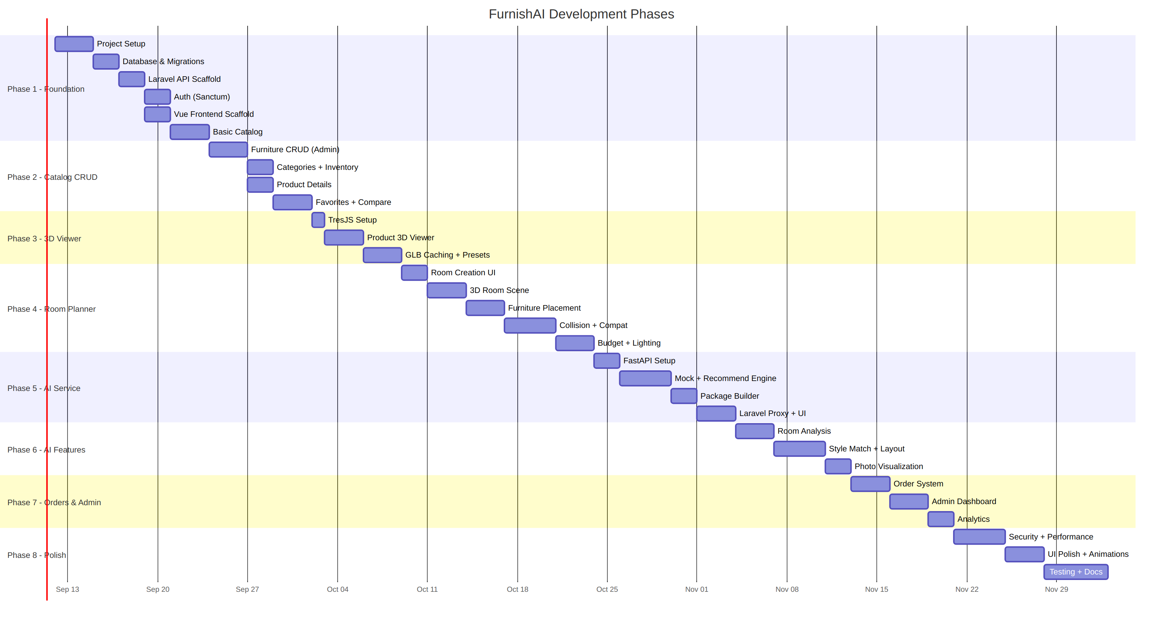
Figure 13.1 — Development phase timeline

Phase 1 — Foundation
SUMMARY — Goal
Standing project with working auth, database, and basic catalog page.

Task | Description
1.1 | Initialize Laravel 11 project
1.2 | Initialize Vue 3 + Vite + TypeScript + Tailwind 4
1.3 | Create all 16+ database migrations
1.4 | Create Eloquent models with relationships
1.5 | Create seeders (roles, categories, 30+ furniture items)
1.6 | Configure Sanctum for SPA auth
1.7 | Build auth endpoints (register, login, logout, profile)
1.8 | Build Vue auth pages (login, register)
1.9 | Create shared BaseComponents
1.10 | Build basic catalog page (grid, pagination)
1.11 | Configure Vue Router with auth guards

Deliverables:
- User can register and login
- Catalog shows furniture from DB
- Basic filtering + pagination
- Admin & customer roles

Phase 2 — Catalog & Management
SUMMARY — Goal
Complete CRUD, product details, favorites, comparison.

Task | Description
2.1 | Admin furniture CRUD
2.2 | Multi-image upload
2.3 | GLB model upload
2.4 | Category management
2.5 | Inventory management
2.6 | Product details page
2.7 | Advanced filters (price, size, style, color, material)
2.8 | Full-text search
2.9 | Favorites system
2.10 | Comparison system (up to 4 items)

Phase 3 — 3D Integration
SUMMARY — Goal
Interactive 3D product viewer using TresJS.

Task | Description
3.1 | Install TresJS + Cientos + Three.js
3.2 | Create Product3DViewer component
3.3 | GLB loading with Draco decompression
3.4 | OrbitControls (rotate, zoom, pan)
3.5 | Camera presets (front, side, top, 3/4)
3.6 | Loading progress indicator
3.7 | Model caching composable
3.8 | Integrate into product details page
3.9 | Create sample placeholder GLB models

Phase 4 — Room Planner
SUMMARY — Goal
Full 3D room editor with placement, collision, compatibility, lighting, budget.

Task | Description
4.1 | Room creation form (dimensions, type, style)
4.2 | 3D room scene (floor, walls, ceiling)
4.3 | Furniture picker sidebar
4.4 | Add furniture (GLB at correct scale)
4.5 | Drag to move (constrained to room)
4.6 | Rotate furniture (Y-axis)
4.7 | Duplicate and remove
4.8 | AABB collision detection
4.9 | Space compatibility algorithm
4.10 | Compatibility panel
4.11 | Budget panel
4.12 | 5 lighting presets
4.13 | 2D top-down view toggle
4.14 | Save/load room designs
4.15 | Room image upload

Phase 5 — AI Service
SUMMARY — Goal
FastAPI AI service with recommendations and room packages.

Task | Description
5.1 | Initialize FastAPI project
5.2 | Pydantic request/response models
5.3 | AIProvider interface (strategy pattern)
5.4 | MockProvider (dev fallback)
5.5 | Rule-based recommendation engine
5.6 | Room package builder
5.7 | Laravel AIServiceClient
5.8 | AIProxyController
5.9 | Recommendation UI (Vue)
5.10 | Room package UI (Vue)
5.11 | Health check + graceful degradation

Phase 6 — Advanced AI Features
SUMMARY — Goal
Room analysis, style matching, layout suggestions, photo visualization.

Task | Description
6.1 | Room photo upload + storage
6.2 | Room analysis endpoint
6.3 | Real AI provider (OpenAI / Gemini)
6.4 | Room analysis results UI
6.5 | Style matching endpoint + UI
6.6 | Layout suggestion endpoint
6.7 | Layout visualization in planner
6.8 | Photo overlay visualization
6.9 | AI status indicator
6.10 | Clear AI vs deterministic labeling

Phase 7 — Orders & Admin
SUMMARY — Goal
Simple order/reservation system + admin dashboard.

Task | Description
7.1 | Order creation workflow
7.2 | Order review page
7.3 | Order status tracking
7.4 | Admin order management
7.5 | Admin dashboard (stats, charts)
7.6 | Customer management
7.7 | Room/design analytics
7.8 | Furniture popularity analytics

Phase 8 — Polish & Testing
SUMMARY — Goal
Production-quality finish.

Task | Description
8.1 | Security audit (CSRF, XSS, SQLi, uploads)
8.2 | Rate limiting
8.3 | 3D performance (lazy loading, LOD)
8.4 | Image optimization (thumbnails, WebP)
8.5 | UI animations & transitions
8.6 | Responsive design (mobile, tablet)
8.7 | Error handling & toast feedback
8.8 | PHPUnit API tests
8.9 | Vue component tests (Vitest)
8.10 | Python AI service tests (pytest)
8.11 | E2E tests
8.12 | Complete documentation

14 — Environment & Configuration

Backend .env
# Application
APP_NAME=SmartSpace
APP_ENV=local
APP_KEY=
APP_DEBUG=true
APP_URL=http://localhost:8000

# Database
DB_CONNECTION=mysql
DB_HOST=127.0.0.1
DB_PORT=3306
DB_DATABASE=SmartSpace
DB_USERNAME=root
DB_PASSWORD=

# Sanctum
SANCTUM_STATEFUL_DOMAINS=localhost:5173,localhost:3000
SESSION_DOMAIN=localhost
SESSION_DRIVER=database

# CORS
CORS_ALLOWED_ORIGINS=http://localhost:5173

# File Storage
FILESYSTEM_DISK=public
MAX_IMAGE_SIZE_KB=10240
MAX_MODEL_SIZE_KB=20480
ALLOWED_IMAGE_TYPES=jpg,jpeg,png,webp
ALLOWED_MODEL_TYPES=glb

# AI Service
AI_SERVICE_URL=http://localhost:8001
AI_SERVICE_TIMEOUT=30
AI_SERVICE_ENABLED=true

# Rate Limiting
API_RATE_LIMIT=60
AI_RATE_LIMIT=10

Frontend .env
VITE_API_BASE_URL=http://localhost:8000
VITE_APP_NAME=SmartSpace
VITE_DRACO_DECODER_PATH=/draco/

AI Service .env
# Server
HOST=0.0.0.0
PORT=8001
DEBUG=true
ENVIRONMENT=development

# AI Provider: openai | gemini | mock
AI_PROVIDER=mock

# OpenAI (when AI_PROVIDER=openai)
OPENAI_API_KEY=sk-...
OPENAI_MODEL=gpt-4o
OPENAI_VISION_MODEL=gpt-4o

# Google Gemini (when AI_PROVIDER=gemini)
GEMINI_API_KEY=
GEMINI_MODEL=gemini-2.0-flash

# Internal Auth (shared secret with Laravel)
SERVICE_API_KEY=your-internal-service-key

# Limits
MAX_IMAGE_SIZE_MB=10
MAX_CATALOG_ITEMS_PER_REQUEST=500

15 — Deployment & DevOps

Local Development
# 1. Backend (Laravel)
cd backend
composer install
cp .env.example .env
php artisan key:generate
php artisan migrate --seed
php artisan storage:link
php artisan serve --port=8000

# 2. Frontend (Vue)
cd frontend
npm install
cp .env.example .env
npm run dev # -> http://localhost:5173

# 3. AI Service (Python)
cd ai-service
python -m venv venv
venv\Scripts\activate # Windows
pip install -r requirements.txt
cp .env.example .env
uvicorn app.main:app --host 0.0.0.0 --port 8001 --reload

Production
Concern | Recommendation
Web Server | Nginx + PHP-FPM
SSL | Required (Let's Encrypt)
Database | MySQL 8 + connection pooling
File Storage | S3-compatible for production
AI Service | Docker container, separate server
Caching | Redis (session, cache, queue)
Queue | Laravel Queue for async AI
CDN | Static assets + GLB models via CDN
Monitoring | Laravel Telescope (dev), Sentry (prod)
Backups | Automated daily DB backups

16 — Testing Strategy

Backend (PHPUnit)
tests/
|-- Feature/
| |-- Auth/RegistrationTest.php
| |-- Auth/LoginTest.php
| |-- Furniture/FurnitureListTest.php
| |-- Furniture/FurnitureCreateTest.php
| |-- Room/RoomProjectTest.php
| |-- Room/SpaceCompatibilityTest.php
| |-- Order/OrderTest.php
| `-- AI/AIProxyTest.php
`-- Unit/
|-- SpaceCompatibilityServiceTest.php
|-- BudgetServiceTest.php
`-- FileUploadServiceTest.php

Frontend (Vitest + Playwright)
Type | Tool | Scope
Unit | Vitest | Composables, utilities, stores
Component | Vitest + @vue/test-utils | Vue component rendering
E2E | Playwright | Full user flows

AI Service (Pytest)
tests/
|-- test_room_analysis.py
|-- test_recommendations.py
|-- test_style_match.py
|-- test_mock_provider.py
`-- test_health.py

Run Commands
# Backend
cd backend && php artisan test

# Frontend
cd frontend && npm run test

# AI Service
cd ai-service && python -m pytest

# Frontend build check
cd frontend && npm run build

17 — Blender Asset Pipeline

Workflow
Step 1: MODEL
-> Create/import furniture model in Blender
-> Target: 10K-30K faces (max 50K)
-> Origin: center-bottom (floor contact)
-> Scale: 1 Blender unit = 1 meter

Step 2: MATERIALS
-> Principled BSDF (PBR)
-> Base Color, Roughness, Metallic, Normal
-> Textures: 1024x1024 (max 2048)
-> JPEG for opaque, PNG for transparent

Step 3: UV MAPPING
-> Proper UV unwrap
-> No overlapping islands
-> Efficient packing

Step 4: EXPORT
-> File -> Export -> glTF 2.0 (.glb)
-> Format: Binary (.glb)
-> Transform: +Y Up
-> Geometry: Apply Modifiers
-> Compression: Draco ON

Step 5: OPTIMIZE
-> npx @gltf-transform/cli optimize input.glb output.glb \
--compress draco --texture-compress webp

Step 6: VALIDATE
-> File size < 5 MB (target 1-2 MB)
-> Opens in Three.js viewer
-> Materials render correctly
-> Scale matches real dimensions

Step 7: UPLOAD
-> Admin panel -> Furniture -> Upload 3D Model
-> Stored: /storage/app/public/furniture/models/

Naming Convention
{style}-{category}-{variant}.glb

Examples:
modern-sofa-001.glb
minimalist-bed-queen-001.glb
scandinavian-dining-table-001.glb
industrial-bookshelf-001.glb

Development Placeholder Models
NOTE
During development, we use simple colored box GLBs generated programmatically:

Placeholder | Dimensions (cm)
placeholder-sofa.glb | 220 × 85 × 90
placeholder-bed.glb | 200 × 45 × 160
placeholder-table.glb | 120 × 75 × 80
placeholder-chair.glb | 50 × 90 × 50
placeholder-wardrobe.glb | 120 × 200 × 60
placeholder-desk.glb | 140 × 75 × 70
placeholder-bookshelf.glb | 80 × 180 × 35
placeholder-tv-stand.glb | 150 × 50 × 40
placeholder-coffee-table.glb | 100 × 45 × 60
placeholder-cabinet.glb | 90 × 90 × 45

18 — Setup Instructions

Prerequisites
Software | Version | Required
PHP | 8.3+ | Yes
Composer | 2.x | Yes
Node.js | 20+ | Yes
npm | 10+ | Yes
MySQL | 8.0+ | Yes
Python | 3.11+ | Yes
Git | 2.x | Yes
XAMPP | 8.3+ | Yes (for local MySQL/PHP)

Quick Start
# Clone / navigate to project
cd c:\xampp\htdocs\new_project

# ===================================
# 1. DATABASE
# ===================================
# Create MySQL database:
mysql -u root -e "CREATE DATABASE SmartSpace CHARACTER SET utf8mb4 COLLATE utf8mb4_unicode_ci;"

# ===================================
# 2. BACKEND (Laravel)
# ===================================
cd backend
composer install
cp .env.example .env
php artisan key:generate
# Edit .env -> set DB credentials
php artisan migrate --seed
php artisan storage:link
php artisan serve --port=8000

# ===================================
# 3. FRONTEND (Vue)
# ===================================
cd ../frontend
npm install
cp .env.example .env
npm run dev
# -> Open http://localhost:5173

# ===================================
# 4. AI SERVICE (Python)
# ===================================
cd ../ai-service
python -m venv venv
venv\Scripts\activate
pip install -r requirements.txt
cp .env.example .env
# Edit .env -> set AI_PROVIDER=mock (for dev)
uvicorn app.main:app --host 0.0.0.0 --port 8001 --reload

# ===================================
# 5. TEST CREDENTIALS (from seeder)
# ===================================
# Admin: admin@SmartSpace.com / password
# Customer: customer@SmartSpace.com / password

Adding a GLB Model
- Create/export model in Blender (see Section 17 — Blender Asset Pipeline)
- Login as Admin → Furniture Management
- Create or edit furniture item
- Upload .glb file in the 3D Model section
- Model appears in Product Details 3D viewer and Room Planner

Configuring AI Provider
- Edit ai-service/.env
- Set AI_PROVIDER to openai, gemini, or mock
- Add API key for chosen provider
- Restart AI service
- Verify: GET http://localhost:8001/health

Quick Reference Tags
#project/SmartSpace #architecture #vue3 #laravel #fastapi #threejs #mysql #ai #3d #room-planner #tailwindcss #typescript #php #python
VISION
“SmartSpace transforms furniture shopping from guessing into planning — from catalog browsing into spatial design — from hoping it fits into knowing it fits.”
Document Version: 1.0 — September 11, 2026
Status: Awaiting Approval

